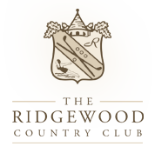
96 W. Midland Avenue
Paramus, New Jersey 07652

We are currently looking for a platform tennis professional to oversee our 2015-2016 paddle program from October 1st thru April 1st. Responsibilities include promoting platform tennis to all ages and genders of our membership, providing individual and group lessons, administering clinics and camps, assisting in interclub teams, running club tournaments and social events. The Ridgewood Country Club has an active and enthusiastic paddle program with over 100 members playing competitively on a weekly basis.
Candidates should possess a minimum of five years’ experience teaching, competing, and managing a platform tennis program. Exceptional racquets skills, good communication skills, organizational and motivational skills are necessary. Membership in either the USPTA or APTA is desired.
Applicants should send a resume to robomannio@aol.com or call 201-401-1325.

